**Week 7-12.React JS-HOL**

**Name-Adi Jain**

**Superset ID- 6390400**

**Hands on**

Create a React Application named “ticketbookingapp” where the guest user can browse the page where the flight details are displayed whereas the logged in user only can book tickets.

The Login and Logout buttons should accordingly display different pages. Once the user is logged in the User page should be displayed. When the user clicks on Logout, the Guest page should be displayed.

**Code**

**File Name: index.js**

import React from 'react';

import ReactDOM from 'react-dom/client';

import App from './App';

import './index.css';

const root = ReactDOM.createRoot(document.getElementById('root'));

root.render(<App />);

**========================================================**

**File Name: AuthContext.js**

import React, { createContext, useState } from 'react';

export const AuthContext = createContext();

export const AuthProvider = ({ children }) => {

  const [isLoggedIn, setIsLoggedIn] = useState(false);

  const login = () => setIsLoggedIn(true);

  const logout = () => setIsLoggedIn(false);

  return (

    <AuthContext.Provider value={{ isLoggedIn, login, logout }}>

      {children}

    </AuthContext.Provider>

  );

};

**========================================================**

**File Name: flights.js**

const flights = [

    { id: 1, from: "New York", to: "London", time: "10:00 AM", price: "$500" },

    { id: 2, from: "Paris", to: "Dubai", time: "2:00 PM", price: "$450" },

    { id: 3, from: "Tokyo", to: "San Francisco", time: "9:00 PM", price: "$600" },

  ];

  export default flights;

**========================================================**

**File Name: FlightList.js**

import React from 'react';

import flights from '../data/flights';

const FlightList = ({ showBooking }) => {

  return (

    <div>

      <h2>Available Flights</h2>

      <ul>

        {flights.map(flight => (

          <li key={flight.id}>

            {flight.from} ➡ {flight.to} | {flight.time} | {flight.price}

            {showBooking && <button style={{ marginLeft: '10px' }}>Book</button>}

          </li>

        ))}

      </ul>

    </div>

  );

};

export default FlightList;

**========================================================**

**File Name: GuestPage.js**

import React from 'react';

import FlightList from './FlightList';

const GuestPage = () => {

  return (

    <div>

      <h1>Welcome, Guest!</h1>

      <p>Please log in to book a flight.</p>

      <FlightList showBooking={false} />

    </div>

  );

};

export default GuestPage;

**========================================================**

**File Name: UserPage.js**

import React from 'react';

import FlightList from './FlightList';

const UserPage = () => {

  return (

    <div>

      <h1>Welcome, User!</h1>

      <FlightList showBooking={true} />

    </div>

  );

};

export default UserPage;

**========================================================**

**File Name: App.js**

import React, { useContext } from 'react';

import { AuthProvider, AuthContext } from './context/AuthContext';

import GuestPage from './components/GuestPage';

import UserPage from './components/UserPage';

function AppContent() {

  const { isLoggedIn, login, logout } = useContext(AuthContext);

  return (

    <div className="App">

      <header>

        <button onClick={isLoggedIn ? logout : login}>

          {isLoggedIn ? 'Logout' : 'Login'}

        </button>

      </header>

      <main>

        {isLoggedIn ? <UserPage /> : <GuestPage />}

      </main>

    </div>

  );

}

function App() {

  return (

    <AuthProvider>

      <AppContent />

    </AuthProvider>

  );

}

export default App;

**========================================================**

**File Name: index.css**

body {

  margin: 0;

  font-family: -apple-system, BlinkMacSystemFont, 'Segoe UI', 'Roboto', 'Oxygen',

    'Ubuntu', 'Cantarell', 'Fira Sans', 'Droid Sans', 'Helvetica Neue',

    sans-serif;

  -webkit-font-smoothing: antialiased;

  -moz-osx-font-smoothing: grayscale;

}

code {

  font-family: source-code-pro, Menlo, Monaco, Consolas, 'Courier New',

    monospace;

}

button {

  padding: 8px 12px;

  margin-bottom: 20px;

  cursor: pointer;

}

**========================================================**

**Output**

**Folder Structure**

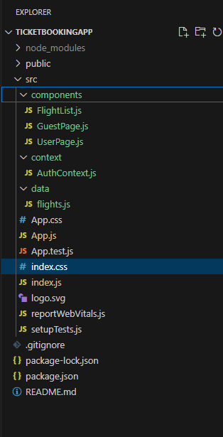

**========================================================**

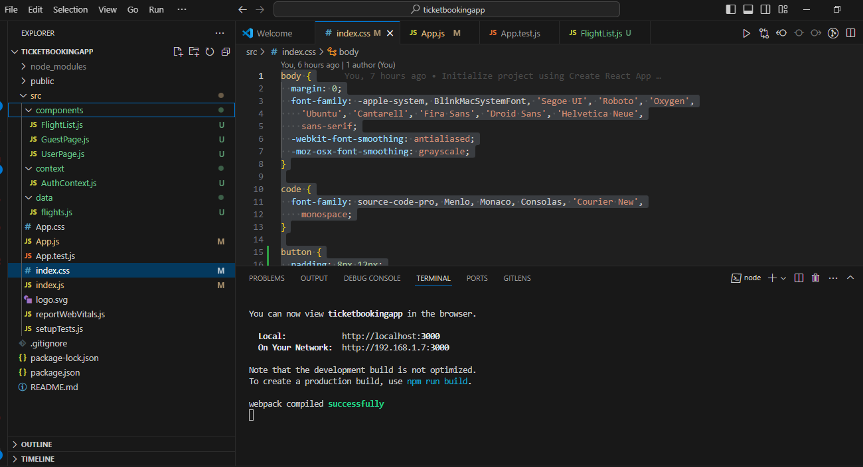

**========================================================**

**Logged Out**

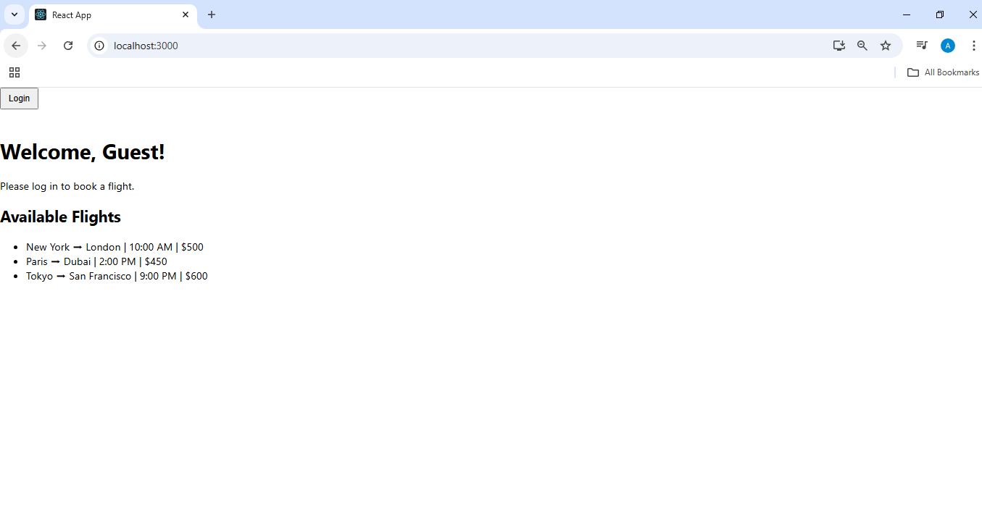

**========================================================**

**Logged in**



